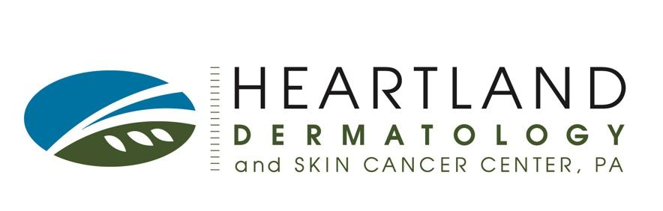
Preparing for Mohs Surgery

You are scheduled for an appointment at Heartland Dermatology, located on the second floor of our East Wichita, Kansas location. Our address is 1861 N. Rock Road, Suite 205, Wichita, KS 67206. Please arrive 20 minutes prior to the appointment time.

For your safety, your surgeon will ask you to correctly identify your surgical site on the day of your procedure. If you are unable to verify the site that requires surgery, your appointment may need to be rescheduled.

Mohs surgery is the surgical excision of skin cancer under local anesthesia in which the tissue is evaluated while you wait. If there is still skin cancer present another section of tissue is taken. This process is repeated until all skin cancer is removed. Reconstruction, if necessary, is usually performed that day. Mohs surgery can take up to eight hours. Please plan accordingly.

If you have any upcoming events, photos, weddings, etc. due to length of recovery time you may want to think about planning the procedure around those special events. Speak to a team member if you have concerns.

One Week Prior to Surgery
- Stop tobacco use. This can interfere with healing after surgery.
- If you take coumadin/warfarin you will be required to have an INR checked within 30 days of your scheduled surgery.

Day of Surgery
- Eat breakfast.
- Take all your usual medications. Bring any medications with you that you may need.
- Bring a tablet, book, crossword puzzle, or craft to do while you wait. You will be required to stay in the office for the duration of the procedure.
- A driver may be required if surgery involves the areas around your nose or eyes. Your driver can leave to get you food. If no one comes with you, have someone on standby.
- Dress warm and bring extra layers. It is cold in the office due to the lab being onsite.

After Surgery
- You will have a pressure dressing in place for 24 to 48 hours.
- You will be asked to refrain from heavy lifting and exercise for up to four weeks.
- You will be required to return in 7 to 14 days for suture removal.

If you have any questions about your surgical procedure, please feel free to contact our Mohs team at (316) 612-1833 during business hours Monday - Friday from 8 AM to 4 PM. If you must cancel or reschedule. We require a 48 hour cancellation notice to accommodate the needs of all our patients.

